**Security testing for** [**https://qwallity.herokuapp.com/**](https://qwallity.herokuapp.com/)

**Used TestR authorization token**

1. [**Update User Role**](https://qwallity.herokuapp.com/swagger/#/Update%20User%20Role) with non_admin authorized user

Nonadmin user – TestR

User with changed role_ID – dbl_user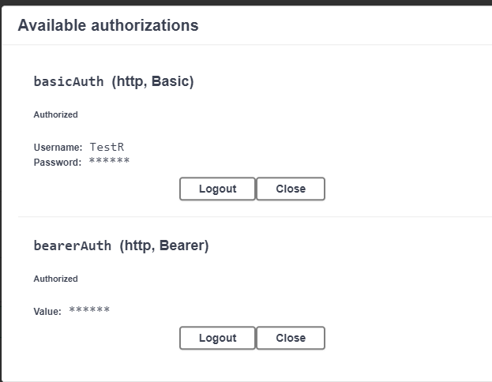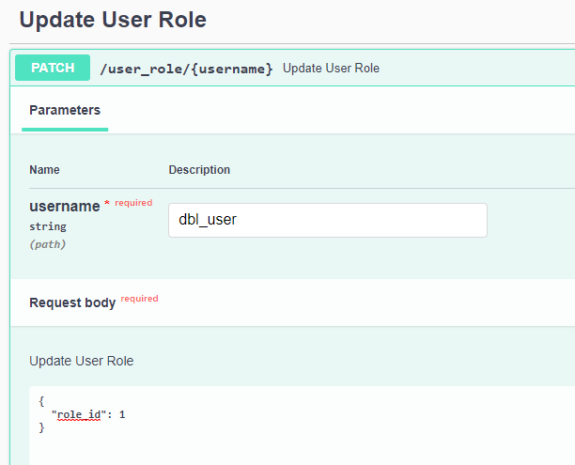

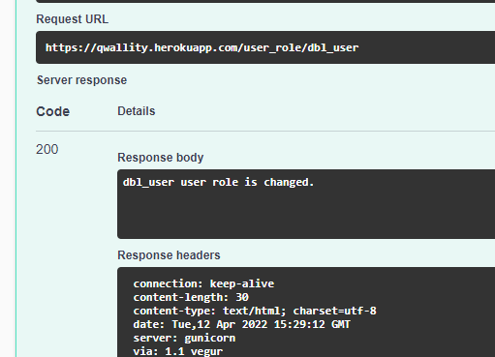

1. [**Register User**](https://qwallity.herokuapp.com/swagger/#/Register%20User) with role_ID =1 (admin user)

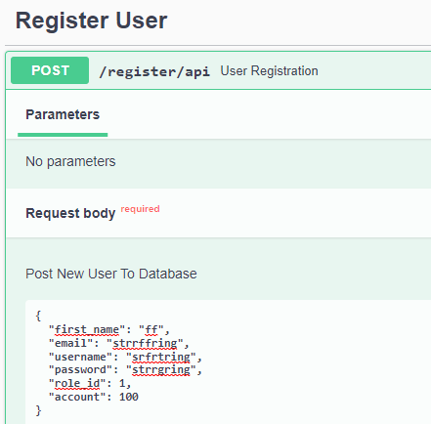

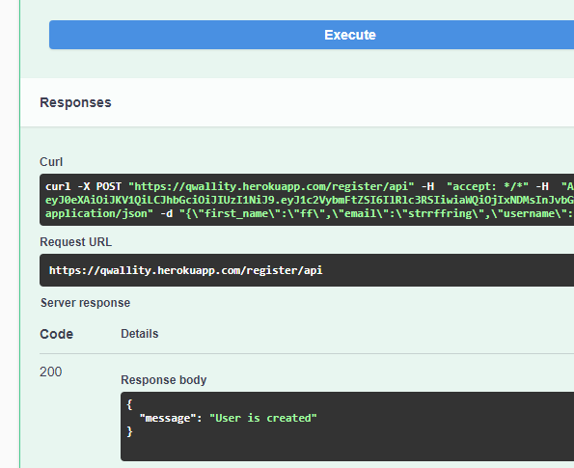

1. [**Get User Account Balance**](https://qwallity.herokuapp.com/swagger/#/Get%20User%20Account%20Balance)

Its available information about non authorized user balance

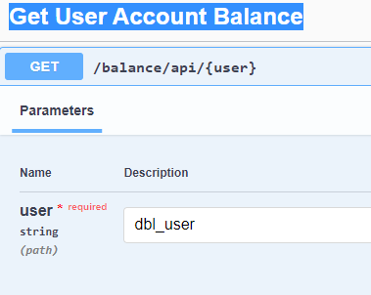

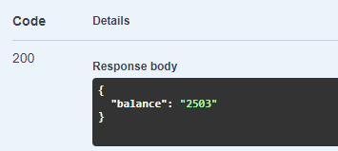

1. [**Buy Course**](https://qwallity.herokuapp.com/swagger/#/Buy%20Course) You can buy a course for every user independent of authorizated user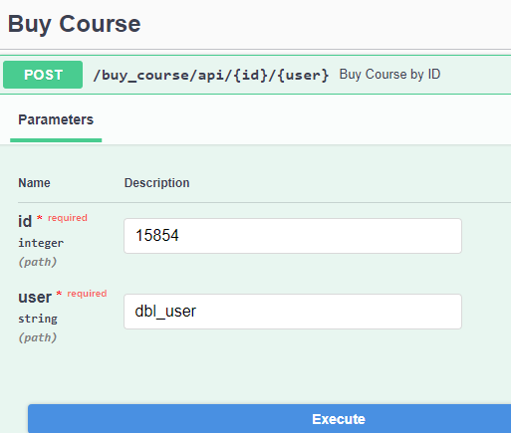

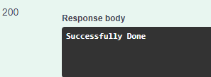

1. [**Add Amount**](https://qwallity.herokuapp.com/swagger/#/Add%20Amount)

You can successfully add an amount to non authorized user account

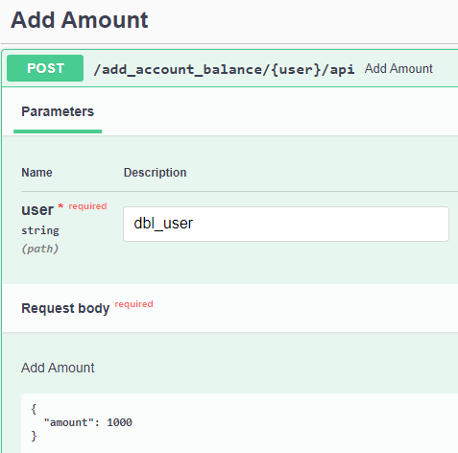

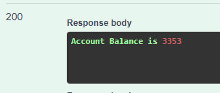

1. [**Get User's Courses**](https://qwallity.herokuapp.com/swagger/#/Get%20User's%20Courses)

You can get courses of any non authorized user 